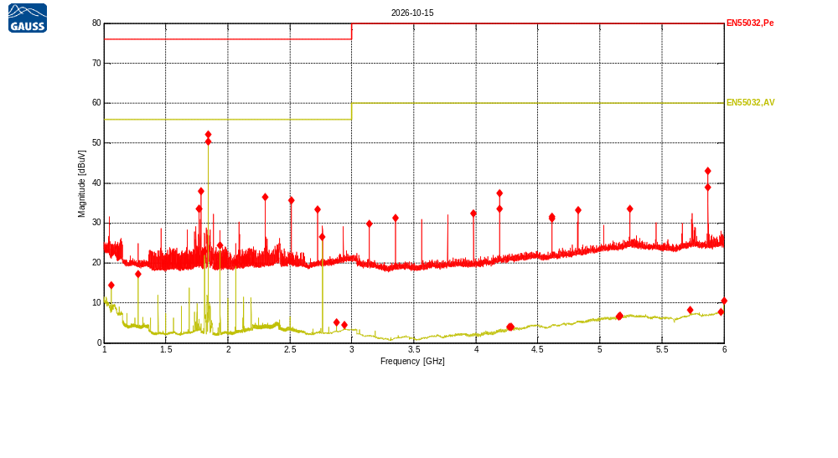
Receiver Model:
Protocol Number:
Serial Number:
Operation State:
Notes:
123123

Traces:
Trace | Start | Step | Stop | IF Bandwidth | Detector | Dwell time | Attenuation | Transducer | LISN | Notes
Scan1 | 1.0 GHz | 500.0 kHz | 6.0 GHz | 1MHz | MaxPeak | 200.0 ms | Auto | TDF1, TDF2 | - | *OVR
Scan2 | 1.0 GHz | 500.0 kHz | 6.0 GHz | 1MHz | Average | 200.0 ms | Auto | TDF1, TDF2 | - | *OVR

Transducers:
TDF1: Kabel Biru
TDF2: Heliax_Cable

Limit lines:
EN55032,Pe: EN55032 Rad 3m,Class A,FSOATS, Peak, 1000MHz-6000MHz
EN55032,AV: EN55032 Rad 3m,Class A,FSOATS, AV, 1000MHz-6000MHz
Scan1: 1.0 GHz, 500.0 kHz, 6.0 GHz; IF:1MHz, 200.0 ms MaxPeak, Att AutodB
f | Mag [dBuV] | Limit | Diff | Polarization | Height [cm] | Angle [°] | Trans | Name | Comment
1.76676002 GHz | 33.48 | 76.00 | 42.52 | V | 100 | 0 | 3.42 | EN55032,Pe
1.76832244 GHz | 33.63 | 76.00 | 42.37 | V | 100 | 0 | 3.42 | EN55032,Pe
1.78277487 GHz | 37.94 | 76.00 | 38.06 | V | 100 | 0 | 3.44 | EN55032,Pe
1.84253762 GHz | 52.21 | 76.00 | 23.79 | H | 100 | 165 | 3.51 | EN55032,Pe
2.30228115 GHz | 36.53 | 76.00 | 39.47 | H | 100 | 0 | 4.01 | EN55032,Pe
2.51203669 GHz | 35.74 | 76.00 | 40.26 | H | 100 | 0 | 4.21 | EN55032,Pe
2.72218284 GHz | 33.34 | 76.00 | 42.66 | H | 100 | 15 | 4.41 | EN55032,Pe
3.14286574 GHz | 29.76 | 80.00 | 50.24 | H | 100 | 15 | 4.83 | EN55032,Pe
3.35223068 GHz | 31.27 | 80.00 | 48.73 | H | 100 | 15 | 5.06 | EN55032,Pe
3.98305973 GHz | 32.34 | 80.00 | 47.66 | H | 100 | 15 | 5.76 | EN55032,Pe
4.19164345 GHz | 33.51 | 80.00 | 46.49 | H | 100 | 15 | 5.98 | EN55032,Pe
4.19281527 GHz | 37.47 | 80.00 | 42.53 | H | 100 | 15 | 5.98 | EN55032,Pe
4.61232635 GHz | 31.54 | 80.00 | 48.46 | H | 100 | 15 | 6.41 | EN55032,Pe
4.61310757 GHz | 31.09 | 80.00 | 48.91 | H | 100 | 0 | 6.41 | EN55032,Pe
4.82286311 GHz | 33.15 | 80.00 | 46.85 | H | 100 | 0 | 6.61 | EN55032,Pe
5.24237419 GHz | 33.47 | 80.00 | 46.53 | H | 100 | 0 | 6.97 | EN55032,Pe
5.87203142 GHz | 42.95 | 80.00 | 37.05 | H | 100 | 0 | 7.46 | EN55032,Pe
5.87281264 GHz | 38.99 | 80.00 | 41.01 | H | 100 | 15 | 7.46 | EN55032,Pe

Scan2: 1.0 GHz, 500.0 kHz, 6.0 GHz; IF:1MHz, 200.0 ms Average, Att AutodB
f | Mag [dBuV] | Limit | Diff | Polarization | Height [cm] | Angle [°] | Trans | Name | Comment
1.062497 GHz | 14.41 | 56.00 | 41.59 | H | 100 | 165 | 2.49 | EN55032,AV
1.27811163 GHz | 17.21 | 56.00 | 38.79 | H | 100 | 210 | 2.78 | EN55032,AV
1.81285155 GHz | 22.92 | 56.00 | 33.08 | H | 100 | 165 | 3.47 | EN55032,AV
1.84253762 GHz | 50.44 | 56.00 | 5.56 | H | 100 | 135 | 3.51 | EN55032,AV
1.93784554 GHz | 24.45 | 56.00 | 31.55 | H | 100 | 60 | 3.62 | EN55032,AV
2.06283953 GHz | 20.09 | 56.00 | 35.91 | H | 100 | 180 | 3.76 | EN55032,AV
2.76319649 GHz | 26.51 | 56.00 | 29.49 | H | 100 | 210 | 4.45 | EN55032,AV
2.87569108 GHz | 5.13 | 56.00 | 50.87 | H | 100 | 150 | 4.56 | EN55032,AV
2.93818808 GHz | 4.55 | 56.00 | 51.45 | H | 100 | 150 | 4.62 | EN55032,AV
4.2697647 GHz | 4.00 | 60.00 | 56.00 | H | 200 | 0 | 6.06 | EN55032,AV
4.27913924 GHz | 4.00 | 60.00 | 56.00 | H | 200 | 0 | 6.07 | EN55032,AV
4.28851379 GHz | 4.06 | 60.00 | 55.94 | H | 200 | 0 | 6.08 | EN55032,AV
5.15292537 GHz | 6.60 | 60.00 | 53.40 | H | 100 | 90 | 6.90 | EN55032,AV
5.1611281 GHz | 6.74 | 60.00 | 53.26 | H | 200 | 0 | 6.90 | EN55032,AV
5.16229992 GHz | 6.73 | 60.00 | 53.27 | H | 300 | 225 | 6.91 | EN55032,AV
5.73024136 GHz | 8.23 | 60.00 | 51.77 | H | 200 | 0 | 7.35 | EN55032,AV
5.97671389 GHz | 7.77 | 60.00 | 52.23 | H | 100 | 90 | 7.54 | EN55032,AV
6 GHz | 10.51 | 60.00 | 49.49 | H | 100 | 105 | 7.56 | EN55032,AV

